Q1. Explain Static keyword in java programming?

Ans:

1. Variables:

When a variable declared static, then a Single copy of the variable is created and shared among all objects of at the class level. Static variable are essentially , global variables.

All Instance of the class share the same static variables.

We can declare static variable at class level

Static variable can access by class name without using of object

If static member in a same class we used without using class Name or Object name.

Static variable recommended to access via className

Syntax:

ClassName.VariableName

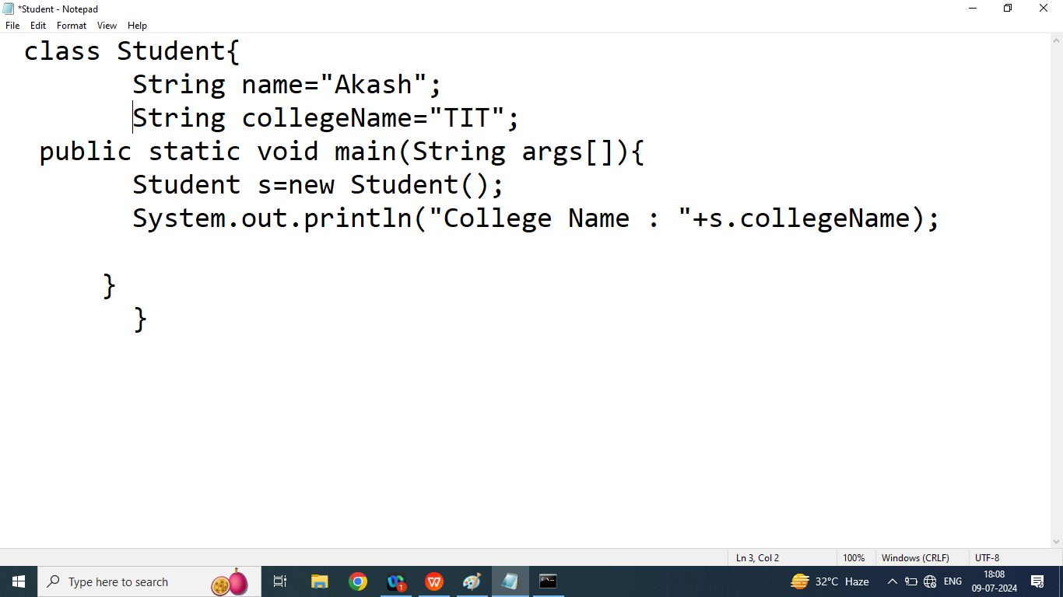

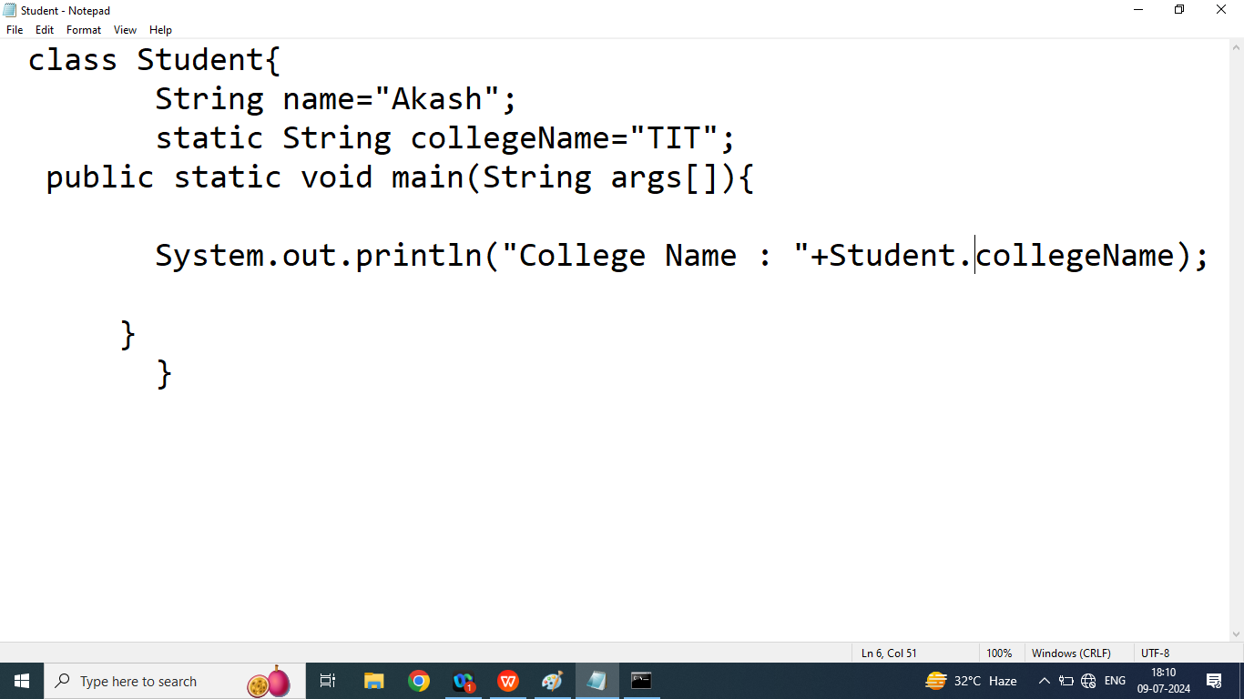

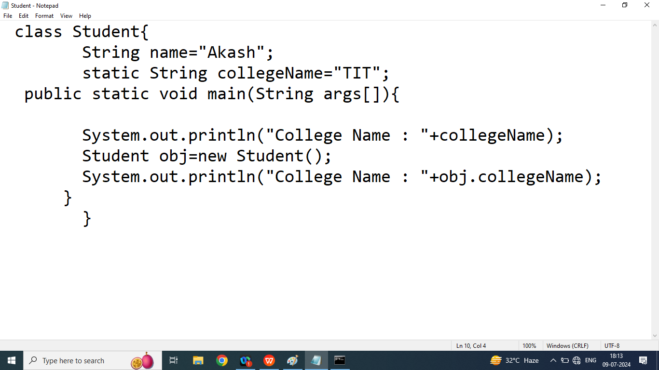

1. Static Block:

Static block is used to initialized a static variable or class level variable

A class can have multiple static block but it can be executed according order they are declared

In java static block are executed before main method

Syntax:

static{

//static block

}

Static method : A method that can be worked only static member

A static method can access using class name(no need to create an object of a class)

Q1. Write a java program to count number of object created

class Student{

String name="Akash";

static String collegeName;

private static int count=0; //static variable

public static int getCount(){

return count;

}

public Student(){

count++;

}

public Student(String name){

this.name=name;

count++;

}

// static block

static{

System.out.println("This is Static Block 2");

}

static{

System.out.println("This is Static Block 1");

collegeName="LNCT";

}

public static void main(String args[]){

System.out.println("This is Main Method");

Student s1=new Student();

Student s2=new Student("Akash");

Student s3=new Student();

System.out.println("Number of Object created : "+Student.getCount());

System.out.println("Number of Object created : "+getCount());

System.out.println("Number of Object created : "+s1.getCount());

System.out.println("College Name : "+collegeName);

}

}

|  |
| --- |
| This is Static Block 2  This is Static Block 1 |
|  |